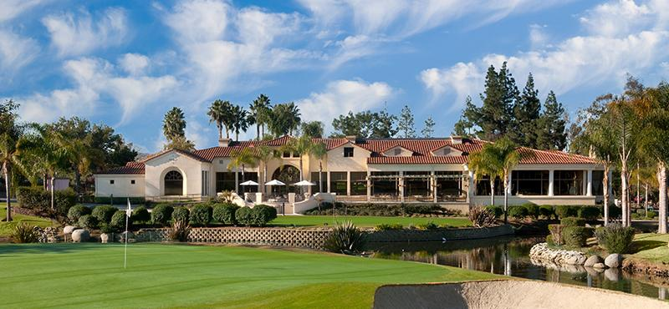
Entry Fees $150.00/person ~ $600.00/ Team
3rd Annual Fundraising Event

The Country Club of Rancho Bernardo

Monday, September 18, 2023

Check in 10:00am ~ Shotgun Start 11:00am ~ Scramble Format

Lunch & Dinner ~ No Host Bar ~ Buffet only $30.00

Raffle Tickets 5 for $20 and Mulligans 2 for $10
Top 3 Teams win entry to Randy Jones Invitational

_____________Fill out ~ tear off ~and return with Check (only)________________

Team Name _____________________ (Have some fun!)
Last First Phone Email
Captain ______________ ________ ___________ _________________

Player 2 ______________ ________ ___________ _________________

Player 3 ______________ ________ ___________ _________________

Player 4 ______________ ________ ___________ _________________

Single _______________ ________ ___________ _________________
Please write your check to TCAF
Send to PO Box 2716, La Mesa, CA 91943

